Quickstart Guide for MP3450 Economy Type
Thanks for using our product MP3450E.
The product is specially designed for Laptops and mobile phones when offering power and charging itself at the same time.

- MP3450E and Accessories

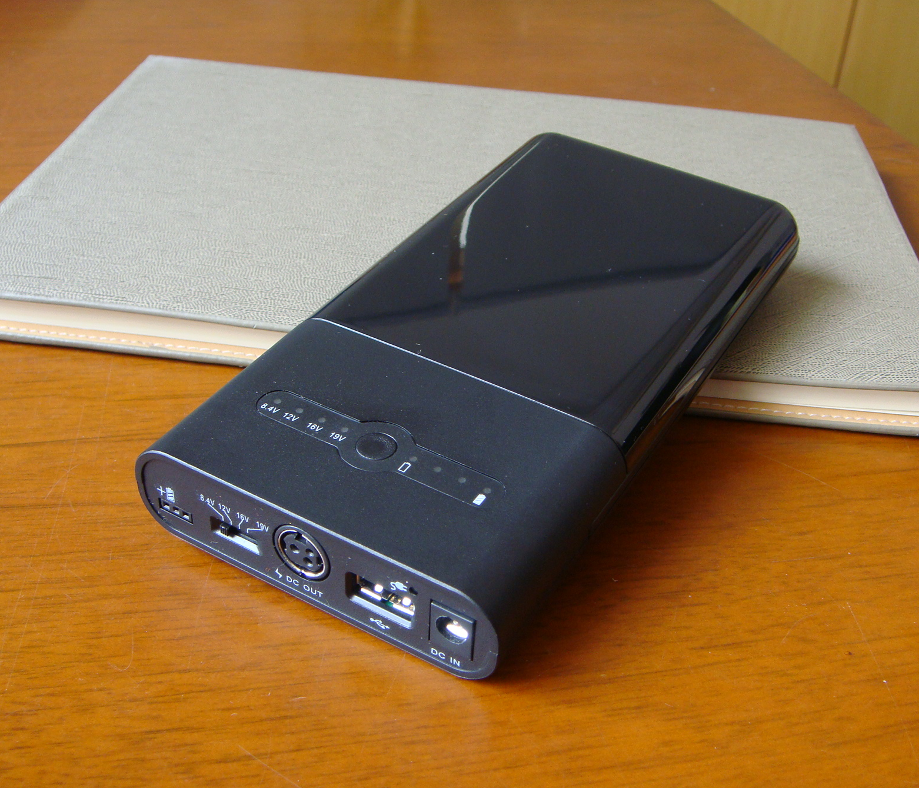
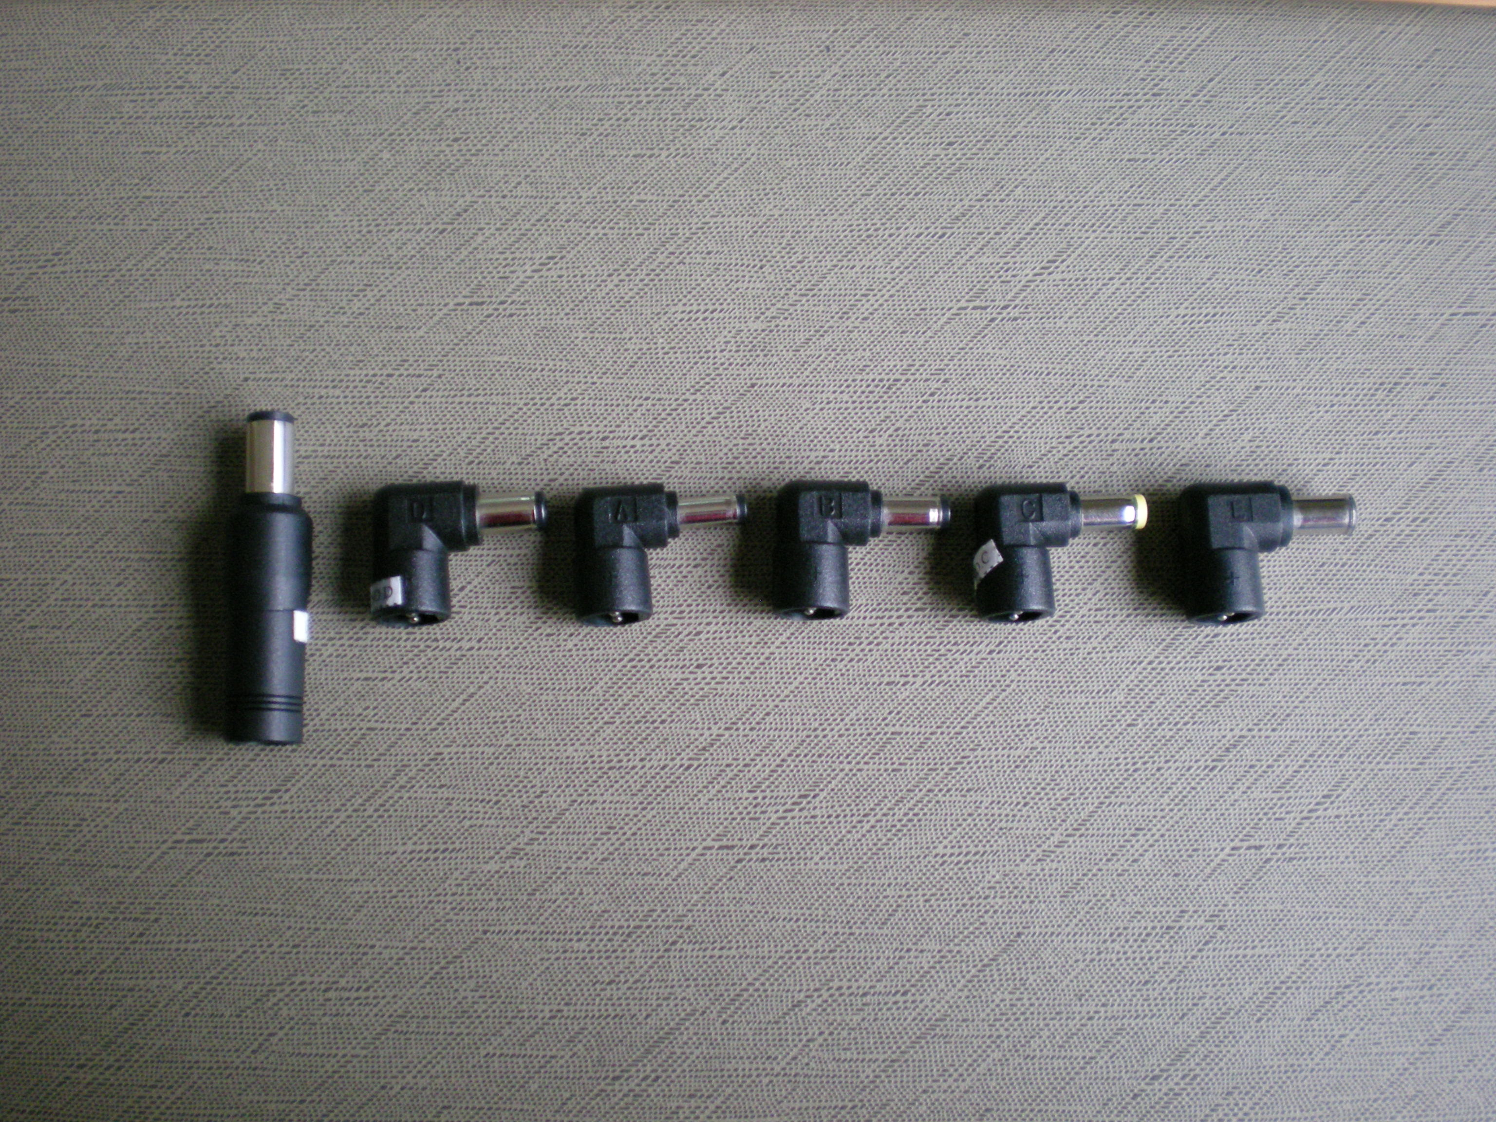
Chargeable Battery Bank

Output Tips

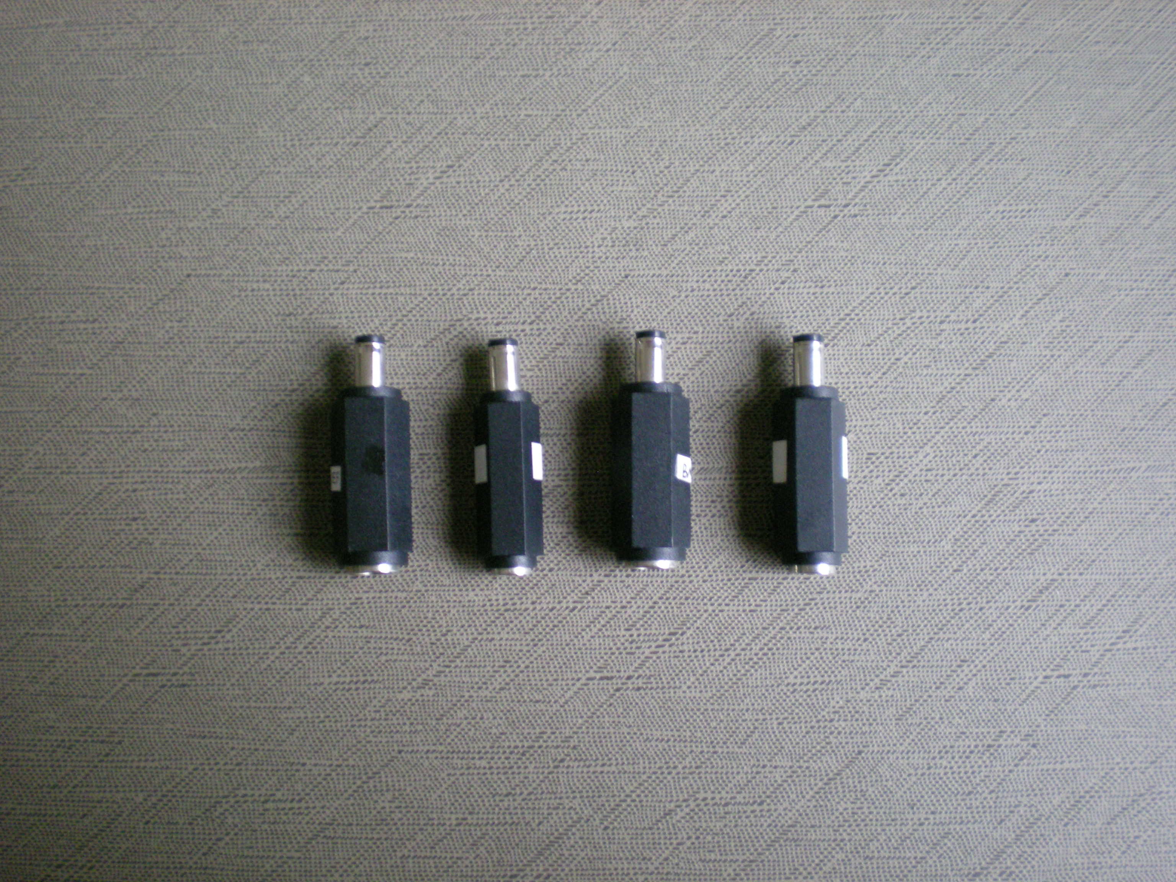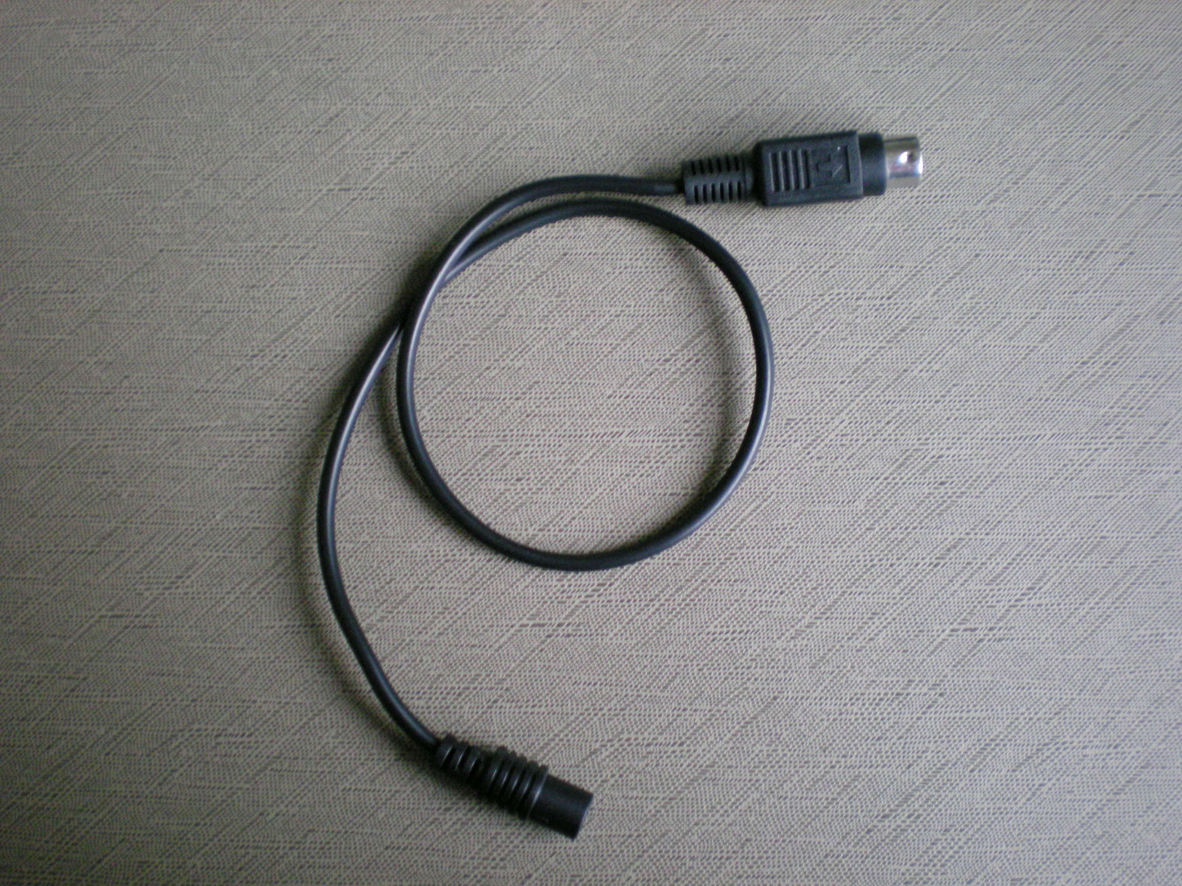
Input Adapter Tips

Power Output Cord

Description of Battery Pack:
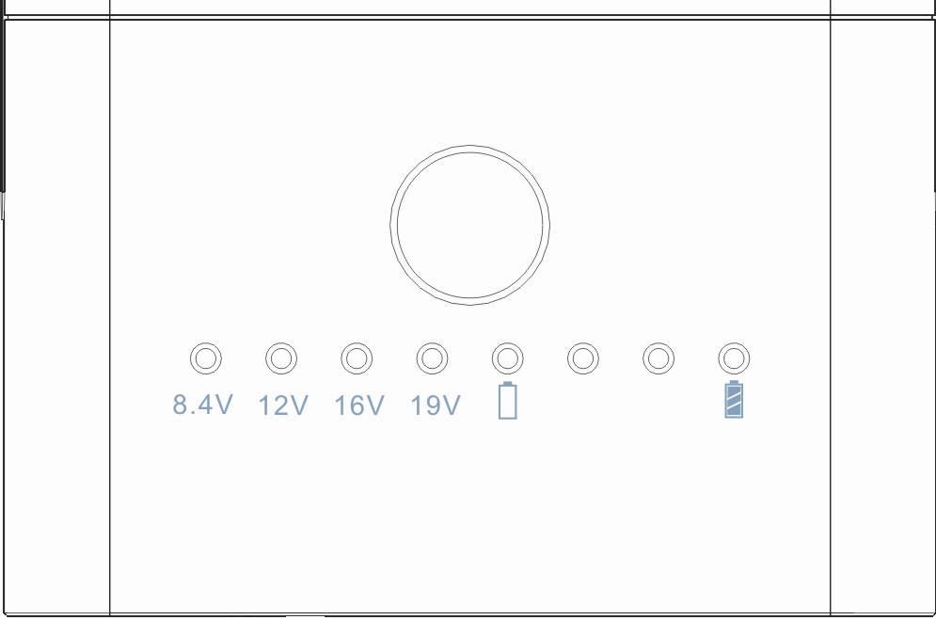
Voltage Indicator
Capacity Indicator
Capacity Display Button
Description of Top Cover

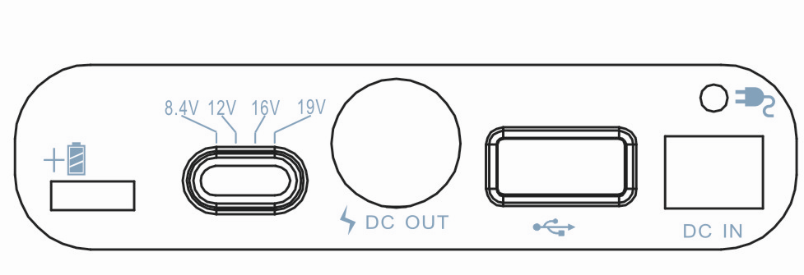
Connection port of Extra Battery
Voltage Selected Switch
For Connection to Device
USB Output Port
For Connection to AC Power Adapter
Charging Indicator

Description of Front Cover

- Output Port of Voltage: 4 Scales of output voltages can be selected (8.4V, 12V, 16V, 19V). The
Constant output current is 4A, and the max current is 4.5A.
- Voltage Selected Switch: 8.4V, 12V, 16V, 19V
- USB Output Port: 5.25V~5.4V / 2 A
- DC IN: 9V ~19V / 0.8A~1.2A, and the charging time is 3.5~ 4.5 hours.
- Charging Indicator: Red( Charge), Green(90% full)
- Connection Port of Extra Battery: To add the capacity of the battery pack, you can choose MP3460.

- Warm Tips
  - MP3450E won’t be turned ON until you plug the power output cord into DC OUT port when you use our product to charge your devices.
  - MP3450E has dual independent output ports, one is the DC OUT port; and the other is USB output port.
  - The setting of MP3450E’s output voltage is on the basis of the output voltage of connected device’s original AC power adapter. Please remember to set suitable voltage before connecting it with your device, or it will damage your device.
  - Please refer to the label of the connected device’s AC power adapter before setting the voltage, which may tell you the voltage should be set.
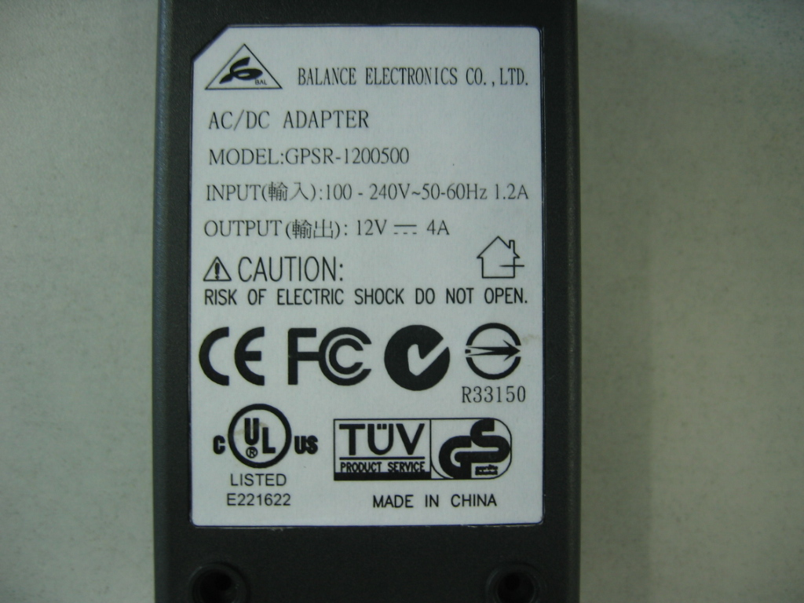
Take this one as an example, the output voltage is 12V.

- Operation Guide

      - Connection of Passing Through Charging ( Indoors )
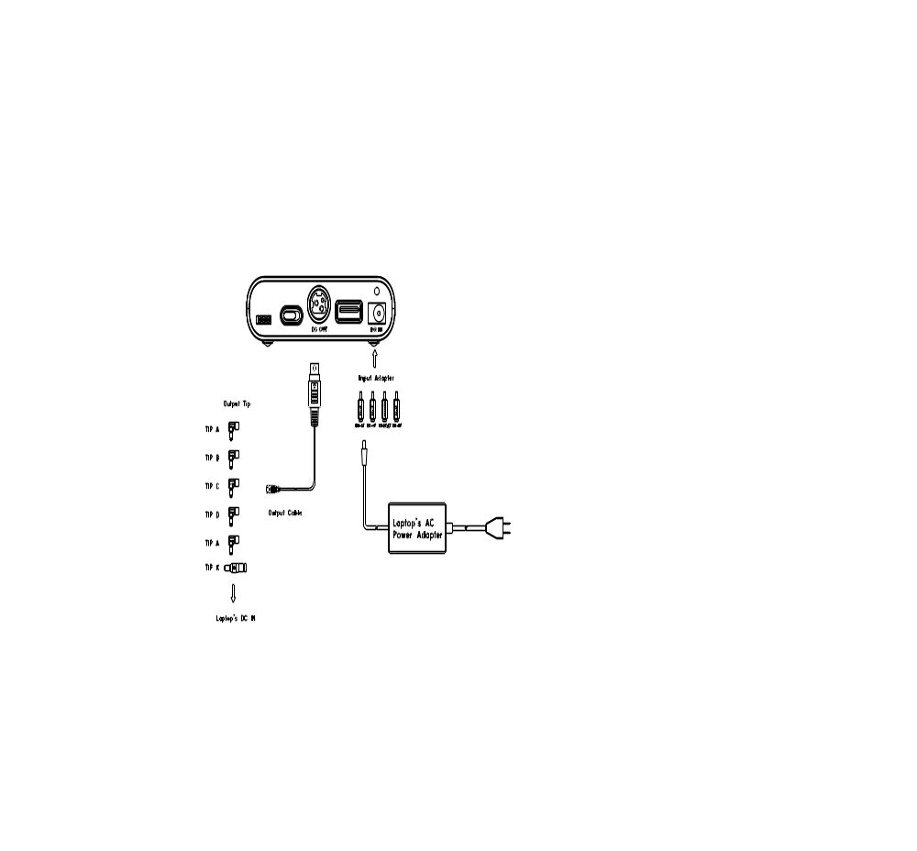
The connection is for passing through charging. That’s to say, it not only can provide working power for your devices and charge its internal battery, but also can charge MP3450E.
** The charging input port must be connected with Laptop’s original AC power adapter or be replaced with another one whose output voltage/current is the same with that of the original one.
The output voltage is same as the charging voltage of DC IN port under this state. You can exchange original AC power adapter for another device if not connected with Laptops. ***

- Connection of Back-up Power (Outdoors)
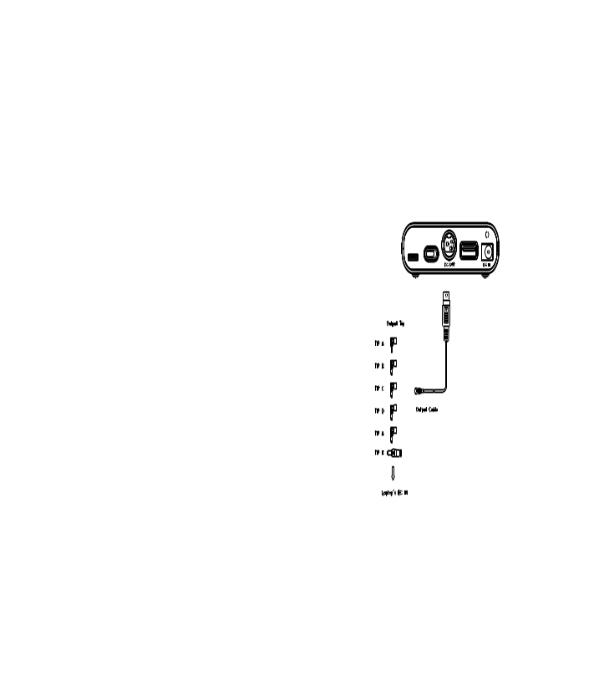
The connection is suitable for being used outdoors. That’s to say, it’s just used as back-up power for
your devices. **** It must set up voltage output finished before connected with laptops or devise; and
can’t change output voltage on working .Otherwise will damaged connected laptops or device ****

    - Remark

Battery Dos:
- Fully charge/discharge battery up to 4 cycles before achieving full capacity of a new battery.
- Remove it from the device and store it under cool and dry environment if the battery is not used for a month or longer.
- Recharge the battery after a long period.
- Must be recycled or properly disposed of used battery.

Battery Don'ts
- Never attempt to disassemble, reassemble.
- Do not short-circuit. A short-circuit may cause severe damage to the battery
- Do not drop, hit or abuse the battery as it may result in the exposure of the battery, which are corrosive.
- Keep battery away from fire or other sources of extreme heat. Exposure of battery to extreme heat may result in an explosion.
- This battery provides 200 discharge/charge cycles. Please avoid frequently plugging and unplugging the AC power adapter.

